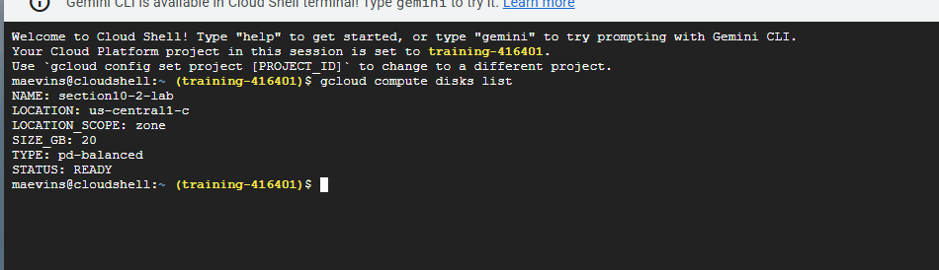
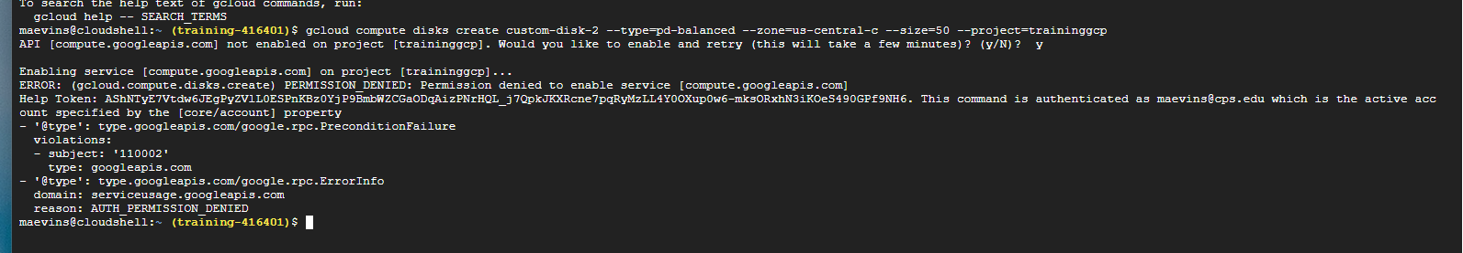
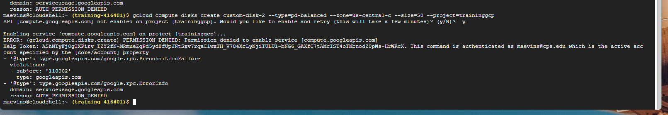

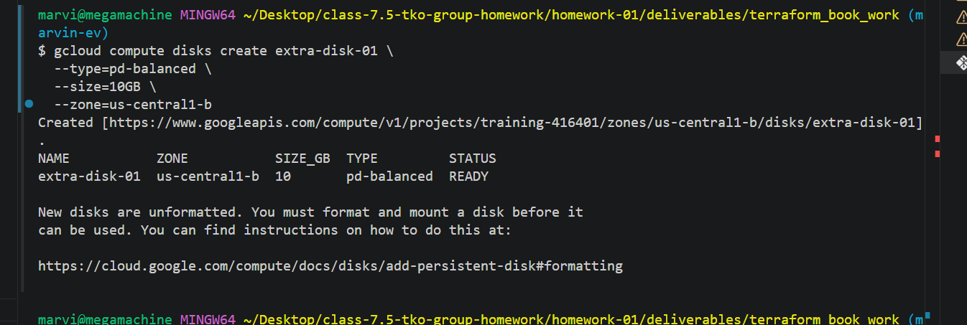

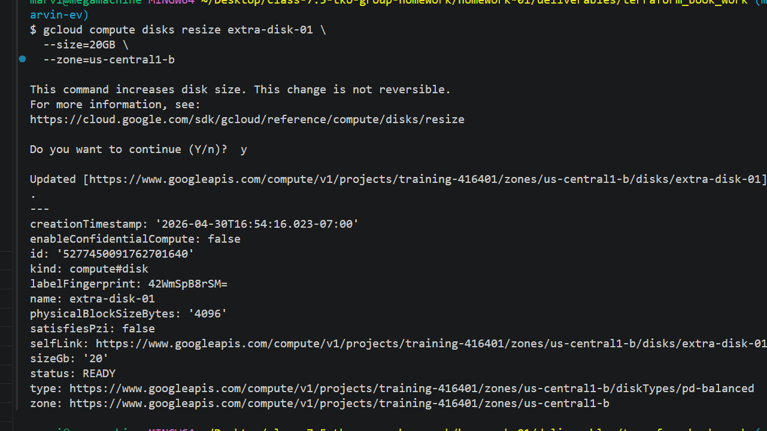

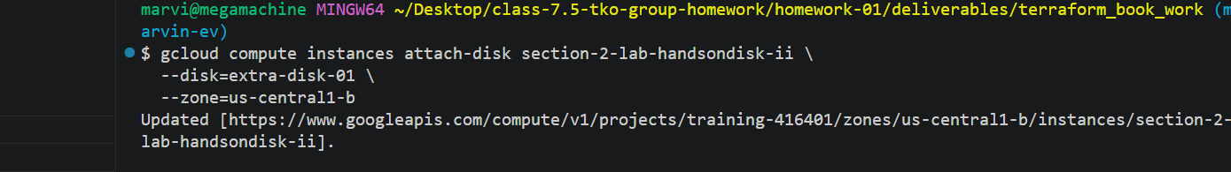
gcloud compute instances describe section-2-lab-handsondisk-ii \
--zone=us-central1-b
canIpForward: false
confidentialInstanceConfig:
enableConfidentialCompute: false
cpuPlatform: Intel Broadwell
creationTimestamp: '2026-04-30T12:22:42.412-07:00'
deletionProtection: false
description: ''
disks:
- architecture: X86_64
autoDelete: true
boot: true
deviceName: section-2-lab-handsondisk-ii
diskSizeGb: '20'
guestOsFeatures:
- type: UEFI_COMPATIBLE
- type: VIRTIO_SCSI_MULTIQUEUE
- type: SEV_CAPABLE
- type: SEV_SNP_CAPABLE
- type: SEV_LIVE_MIGRATABLE
- type: SEV_LIVE_MIGRATABLE_V2
- type: GVNIC
- type: IDPF
- type: TDX_CAPABLE
index: 0
interface: SCSI
kind: compute#attachedDisk
licenses:
- https://www.googleapis.com/compute/v1/projects/centos-cloud/global/licenses/centos-stream-10
mode: READ_WRITE
source: https://www.googleapis.com/compute/v1/projects/training-416401/zones/us-central1-b/disks/section-2-lab-handsondisk-ii
type: PERSISTENT
- autoDelete: false
boot: false
deviceName: persistent-disk-1
diskSizeGb: '20'
index: 1
interface: SCSI
kind: compute#attachedDisk
mode: READ_WRITE
source: https://www.googleapis.com/compute/v1/projects/training-416401/zones/us-central1-b/disks/extra-disk-01
type: PERSISTENT
displayDevice:
enableDisplay: false
fingerprint: xNLFPei2QJc=
id: '4580399117487706861'
keyRevocationActionType: NONE
kind: compute#instance
labelFingerprint: u1i0GMcZHVI=
labels:
goog-ops-agent-policy: v2-template-1-7-0
lastStartTimestamp: '2026-04-30T12:23:06.796-07:00'
machineType: https://www.googleapis.com/compute/v1/projects/training-416401/zones/us-central1-b/machineTypes/e2-medium
metadata:
fingerprint: YcQgntxSNr0=
items:
- key: enable-osconfig
value: 'TRUE'
- key: startup-script
value: |-
#!/bin/bash

apt update -y
apt install -y apache2

cat <<'EOF' > /var/www/html/index.html
<html>
<head>
<title>SEIR Lab Node</title>
<style>
body {
background-color:black;
color:lime;
font-family:monospace;
}
pre {
font-size:14px;
}
</style>
</head>
<body>

<h1>SEIR Infrastructure Node Online</h1>

<pre>

??????????????????????????
??????????????????????????????
??????????????????????????????????
????????????????????????????????????
??????????????????????????????????????
????????????????????????????????????????
????????????????????????????????????????
????????????????????????????????????????
??????????????????????????????????????
????????????????????????????????????
??????????????????????????????????
????????????????????????????????
????????????????????????????
????????????????????????
??????????????????????
????????????????????
????????????????
????????????
????????
????

</pre>

<p>The infrastructure is operational.</p>
<p>Terraform is watching.</p>
<p>Do not anger the state file.</p>

</body>
</html>
EOF

systemctl enable apache2
systemctl restart apache2
kind: compute#metadata
name: section-2-lab-handsondisk-ii
networkInterfaces:
- accessConfigs:
- kind: compute#accessConfig
name: External NAT
natIP: 136.113.117.214
networkTier: PREMIUM
type: ONE_TO_ONE_NAT
fingerprint: YVuOxuKSuzk=
kind: compute#networkInterface
name: nic0
network: https://www.googleapis.com/compute/v1/projects/training-416401/global/networks/main-2
networkIP: 10.1.0.10
stackType: IPV4_ONLY
subnetwork: https://www.googleapis.com/compute/v1/projects/training-416401/regions/us-central1/subnetworks/private-subnet-2
reservationAffinity:
consumeReservationType: ANY_RESERVATION
resourceStatus:
effectiveInstanceMetadata:
enableOsconfigMetadataValue: true
vmDnsSettingMetadataValue: ZonalOnly
satisfiesPzi: false
scheduling:
automaticRestart: true
onHostMaintenance: MIGRATE
preemptible: false
provisioningModel: STANDARD
selfLink: https://www.googleapis.com/compute/v1/projects/training-416401/zones/us-central1-b/instances/section-2-lab-handsondisk-ii
serviceAccounts:
- email: 1075322388602-compute@developer.gserviceaccount.com
scopes:
- https://www.googleapis.com/auth/devstorage.read_only
- https://www.googleapis.com/auth/logging.write
- https://www.googleapis.com/auth/monitoring.write
- https://www.googleapis.com/auth/service.management.readonly
- https://www.googleapis.com/auth/servicecontrol
- https://www.googleapis.com/auth/trace.append
shieldedInstanceConfig:
enableIntegrityMonitoring: true
enableSecureBoot: false
enableVtpm: true
shieldedInstanceIntegrityPolicy:
updateAutoLearnPolicy: true
startRestricted: false
status: RUNNING
tags:
fingerprint: FYLDgkTKlA4=
items:
- http-server
zone: https://www.googleapis.com/compute/v1/projects/training-416401/zones/us-central1-b

marvi@megamachine MINGW64 ~/Desktop/class-7.5-tko-group-homework/homework-01/deliverables/terraform_book_work (marvin-ev)
$

